**1. Data set**

The table is too wide so I cut it into 3 parts. This data set contains the county name, marriage number of each month, total marriage number of each county, which are provided by the assignment document. The dataset also contain the population of each county in 2010, which can be found in this website: <http://www.azcentral.com/community/pinal/articles/20110310census-arizona-new-2010-numbers-brk10-ONbox.html>

Also by normalizing the data I get the marriage rate of each month and the total marriage rate of each county.

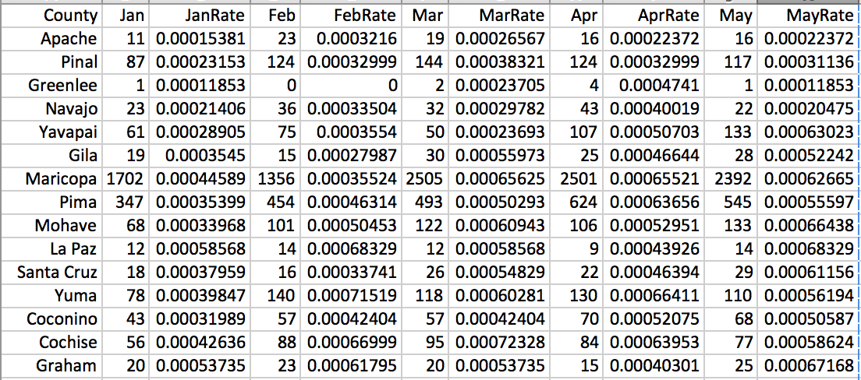

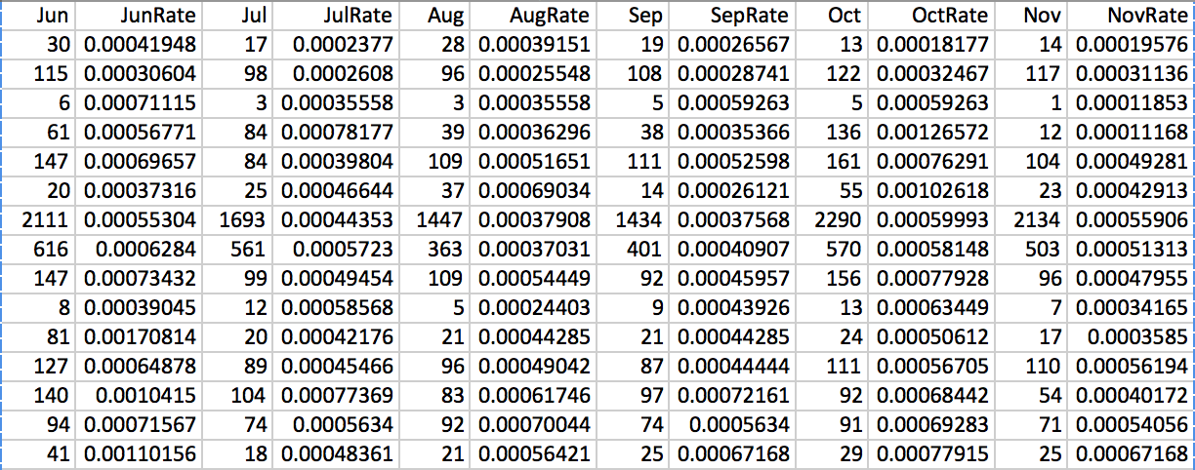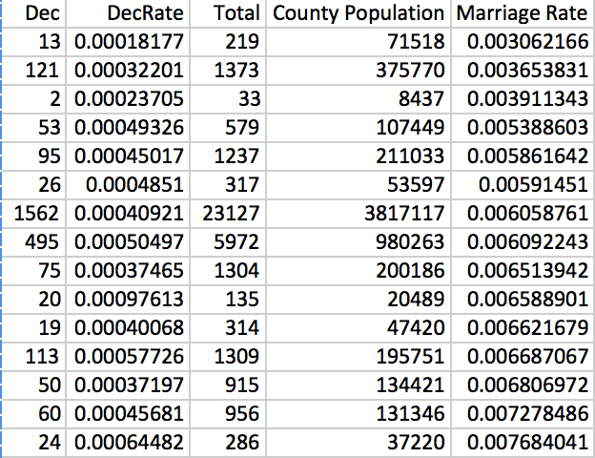

**2. Problem 1 using equal interval classification**

To generate this graph I used 2 columns of the data set, which was county names and total marriage rate of each county. I uploaded the data to the geocommon.com, and chose equal interval classification to generate the graph. The second graph shows the marriage rate range of each color.

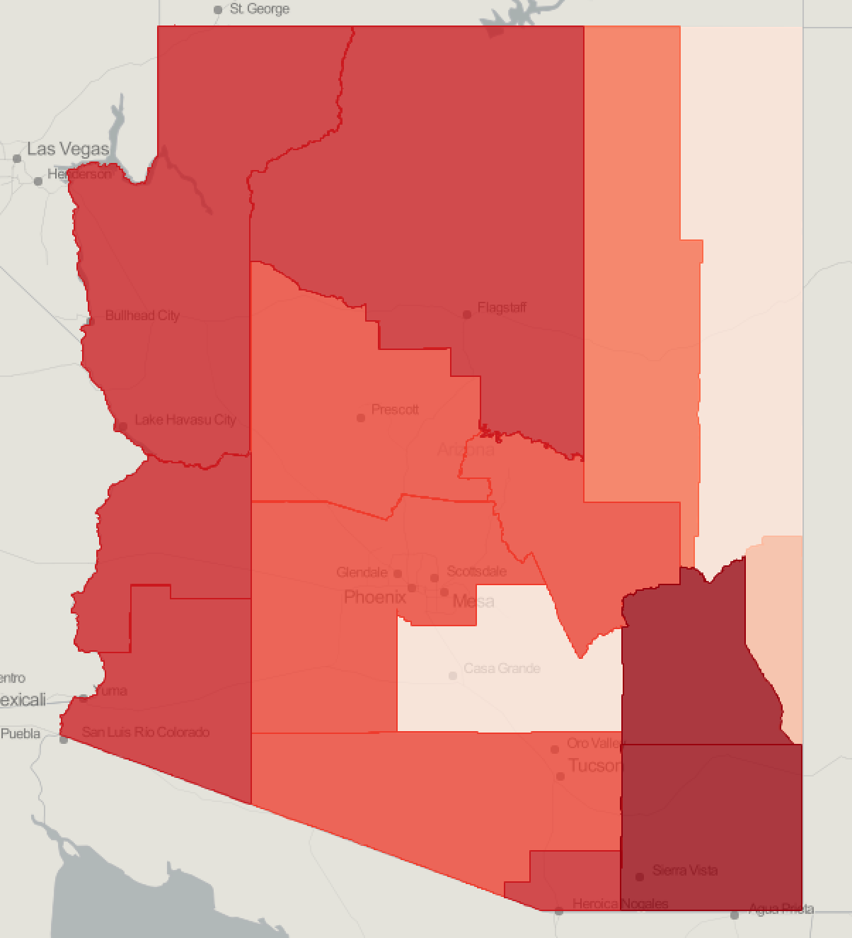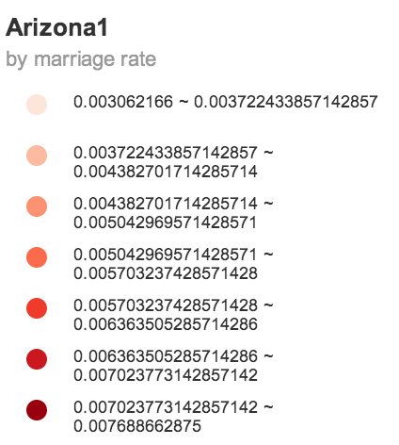

**3. Problem 2 using quantile classification**

To generate this graph I also used 2 columns of the data set, which was county names and total marriage rate of each county. I uploaded the data to the geocommon.com, and chose quantile classification to generate the graph. The second graph shows the marriage rate range of each color.

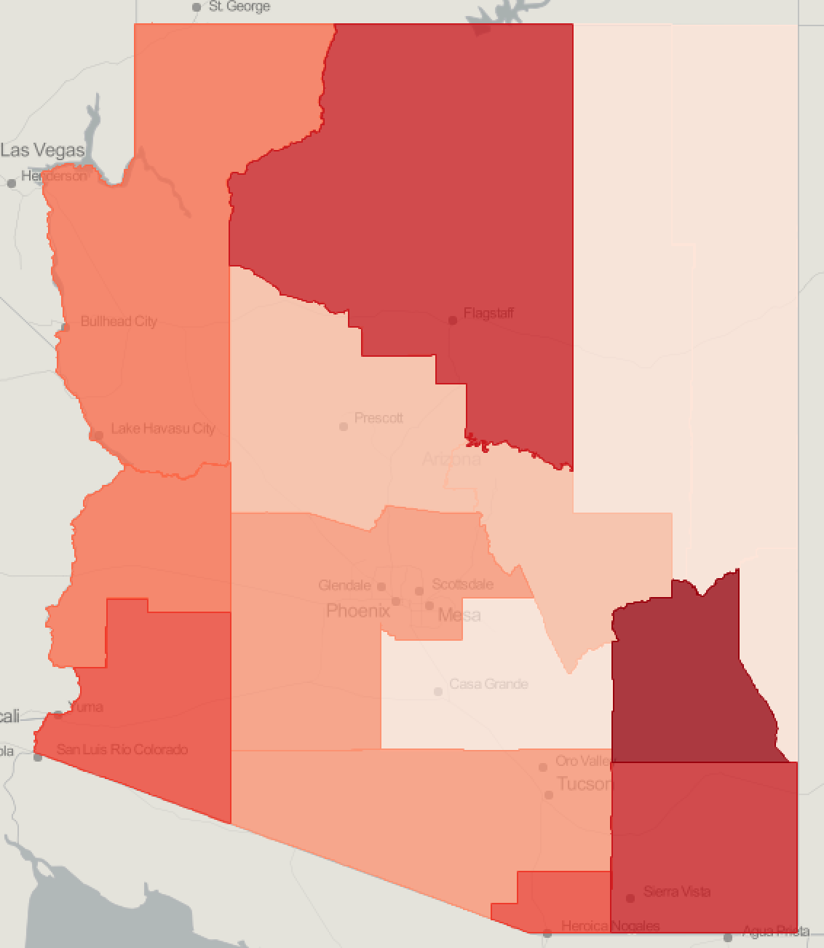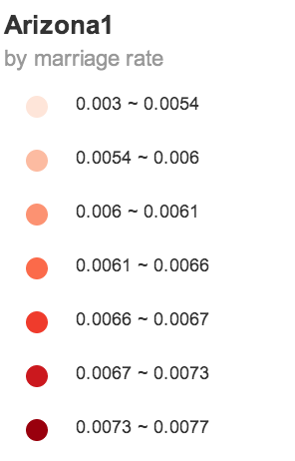

**4. Problem3**

For problem3 I chose quantile classification to classify the data.

The quantile method classifies data into a certain number of categories with an equal number of units in each category, while the equal interval method sets the value ranges in each category equal in size. For this problem, apparently the quantile classification will better show the marriage rate change through months.

